Burkitt Lymphoma
MYC Gene

Burkitt Lymphoma (BL) is a rare and aggressive type of B-cell lymphoma that affects the organs of the immune system. It is a form of undifferentiated malignant lymphoma commonly manifested as a large osteolytic lesion in the jaw or as an abdominal mass. Lymphoma is a cancer originating in the lymphocytes ad presenting as a solid tumor of lymphoid cells. BL accounts for 30-50% of lymphomas in children and 1 to 2% of lymphomas in adults; this disease occurs in more males than females. There are 3 ways that Burkitt Lymphoma can develop: (1) the Epstein Barr virus (EBV); (2) an irregular form that develops mainly in the abdomen; (3) and an immunodeficiency associated form that occurs in individuals infected with HIV. Signs and symptoms vary depending on which form of BL and which organ or body system is affected.
An important gene associated with the progression of Burkitt Lymphoma is the MYC gene (V-Myc Avian Myelocytomatosis Viral Oncogene Homolog) and it is related to the CD40/CD40L pathway, shown in Figure 1. The protein encoded by the MYC gene is a multifunctional, nuclear phosphoprotein that assist in the cell cycle advancement, apoptosis, and cellular transformation. It functions as a transcription factor that regulates transcription of a specific target genes. Transcription factor that binds DNA in a non-specific manner, yet also specifically recognizes the core sequence 5’-CAC[GA]T-3’; activate the transcription of growth related genes. Mutations, overexpression, redisposition, and translocation of this gene have been associated with an assortment of hematopoietic tumors, including Burkitt Lymphoma. These is an indication to show that alternative translation initiations from an upstream, in frame non-AUG (CUG) and a downstream AUG start site result in the production of two isoforms with distinct N-termini. The synthesis of non-AUG initiated protein is suppressed in Burkitt’s Lymphomas, suggesting its importance in the normal function of this gene.
Inherited disturbances of lymphocytes was thought to underlie the familial aggregation for Burkitt Lymphoma. Cytogenetics is the study of inheritance in relation to the function and structure of chromosomes. The MYC gene is located on chromosome 8 in position q24.21, mutations can also happen at q2, 14, or 22 depending on which one of the 3 Burkitt Lymphoma has developed. The type of immunoglobins produced by this B-cell tumor correlates with the q24 type of translocation because of the activation of an oncogene. Haluska et al. (1987) suggested the following scenario for African Burkitt lymphoma: EBV is a polyclonal activator of B lymphocytes, and infection of normal B cells in vitro by EBV is associated with immortalization. In regions of equatorial Africa where Burkitt lymphoma is endemic, 80% of children demonstrate evidence of EBV infection. Translocation involving the IgH locus leads to deregulation of the MYC oncogene. In Europe and North America, childhood EBV infection is less frequent. Burkitt lymphoma appears to occur in mature B cells following antigenic stimulation and during isotype switching. EBV is associated with nearly all BL in Africa, but is only associated with 20% or fewer cases of sporadic BL worldwide. All BL tumors share the translocation of Ig and MYC genes.
The gene has a total of 439 amino acids and weighs 48,804 Da. This gene takes on a quaternary structure and is in the family of the basic helix-loop-helix proteins. This gene also takes on post-translational modifications which leads to the stabilization of MYC. This gene is mostly located in the nucleus and associated regions (such as the nucleoplasm and nucleolus) as well as the cytosol. The human phenotype ontology for the MYC gene is Burkitt Lymphoma but are also associated with abnormality of blood and blood-forming tissues and hematological neoplasm. The gene ontology and biological process for MYC gene are: negative regulation of transcription from RNA polymerase II promoter, MAPK cascade, branching involved in ureteric bud morphogenesis, positive regulation of mesenchymal cell proliferation, and energy reserve metabolic process.
BL is a cancer that begins in cells of the immune system and is more common in equatorial Africa than in Western countries. Cure rates for BL in Western countries approach 90 percent in children, which is higher than adult cure rates seen prior to this new method to treatment, whereas only 30 percent to 50 percent of children in Africa are cured due to an inability to safely administer high-dose treatment. Thus, there is a significant need for less lethal and more effective therapies. Wyndham H. Wilson M.D. Ph.D., head of NCI’s Lymphoma Therapeutics Section, and colleagues directed the trial at NIH’s Clinical Center. The trial involved two variants of EPOCH-R, a chemotherapy regimen that includes the drugs etoposide (E), prednisone (P), vincristine (Oncovin), cyclophosphamide (C), doxorubicin (Hydrodoxorubicin), and rituximab (R). EPOCH-R involves longer exposures to lower concentrations of drugs instead of briefer exposures to higher concentrations of drugs. Thirty patients that were never treated for Burkitt Lymphoma were included in this trial. Depending on the patient’s HIV status, they received one of the two EPOCH-R variants. BL is a disease that occurs recurrently in immune-suppressed AIDS patients. Nineteen HIV-negative patients received dose-adjusted (DA)-EPOCH-R, whereas 11 HIV-positive patients received SC-EPOCH-RR, which is a short-course variant of EPOCH-R that includes two doses of rituximab per treatment cycle and has a lower treatment intensity than DA-EPOCH-R. Doses can be adjusted depending on the patient’s tolerance levels. The average age for the patients were 33 years old. The primary toxicities seen in the trial were fever and neutropenia (low white blood cell counts); no treatment-related deaths occurred in this trial. With follow-up months later, the overall survival rates were 100 percent and 90 percent, respectively, with DA-EPOCH-R and SC-EPOCH-RR. “The toxicity of EPOCH-R-based treatment in Burkitt lymphoma is considerably less than that reported with standard Burkitt regimens,” said Wilson. “Furthermore, these two regimens were highly effective in adult patients, who have significantly worse outcomes than children.” “These promising results with low-toxicity treatment suggest that this approach may be effective and worth investigating in certain geographic and economically challenged regions where Burkitt lymphoma is highly prevalent as well as in adult populations,” said Kieron Dunleavy M.D., NCI, and first author of the study.
Targeted therapy is genetic evidence that has transfigured scientific discovery and drug development in current years by providing distinct relations between genes and disease. Target therapy is to “target” one or several critical biological molecules of malignant cells or a treatment directed toward a group of patients with similar phenotype, genetic, or epigenetic features. Medicine established with human genetic evidence have had significantly advanced success rates and has profited patient care. BL is an hostile B-cell neoplasm that is now treated by rigorous chemotherapy in combination with anti-CD20 antibodies. Due to their toxicity, current treatment regimens are often not appropriate for elderly patients or for patients in emerging countries where BL is prevalent. Targeted therapies are therefore needed for this disease. In this study, they performed a compound in 17 BL cell lines to identify small molecule inhibitors affecting cell survival. So, they found out that inhibitors of HSP90 induces apoptosis in BL cells in vitro at concentrations that did not distress normal B cells. By global proteomic and phosphoproteomic profiling, they showed that, in Burkitt Lymphoma, HSP90 inhibition compromises the activity of the pivotal B-cell antigen receptor (BCR)-proximal effector spleen tyrosine kinase (SYK), which they identified as an HSP90 protein. Steadily, expression of constitutively active TEL-SYK counteracted the apoptotic effect of HSP90 inhibition. Together, their outcomes validate that HSP90 inhibition impairs BL cell survival by interfering with tonic BCR signaling, thus providing molecular rationale for the use of HSP90 inhibitors in the treatment of Burkitt Lymphoma. Figure 2 shows the relationship between B-cell receptor, SYK, and the MYC gene.

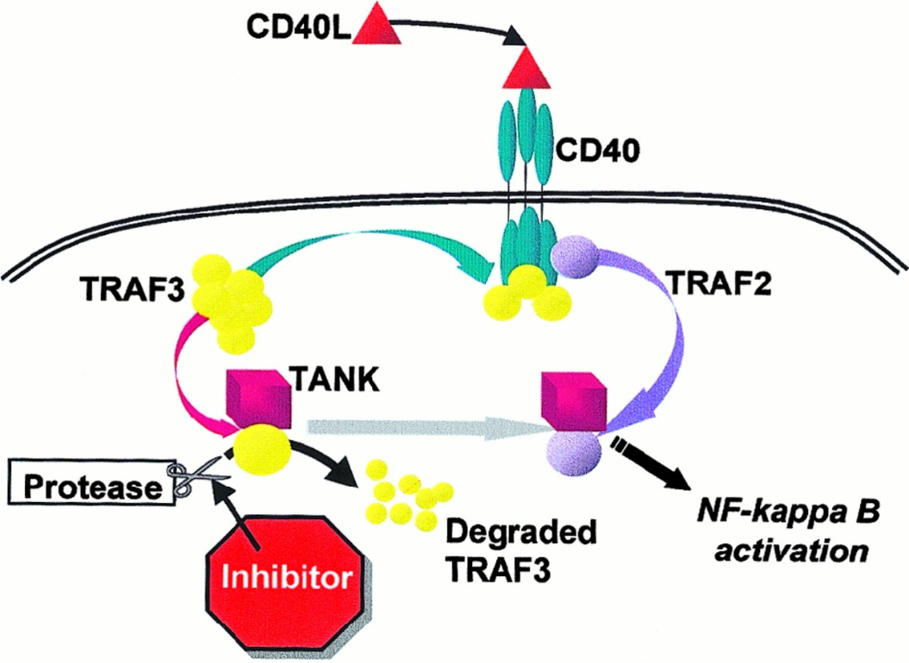
Figure 1. The CD40/CD40L signaling pathway.

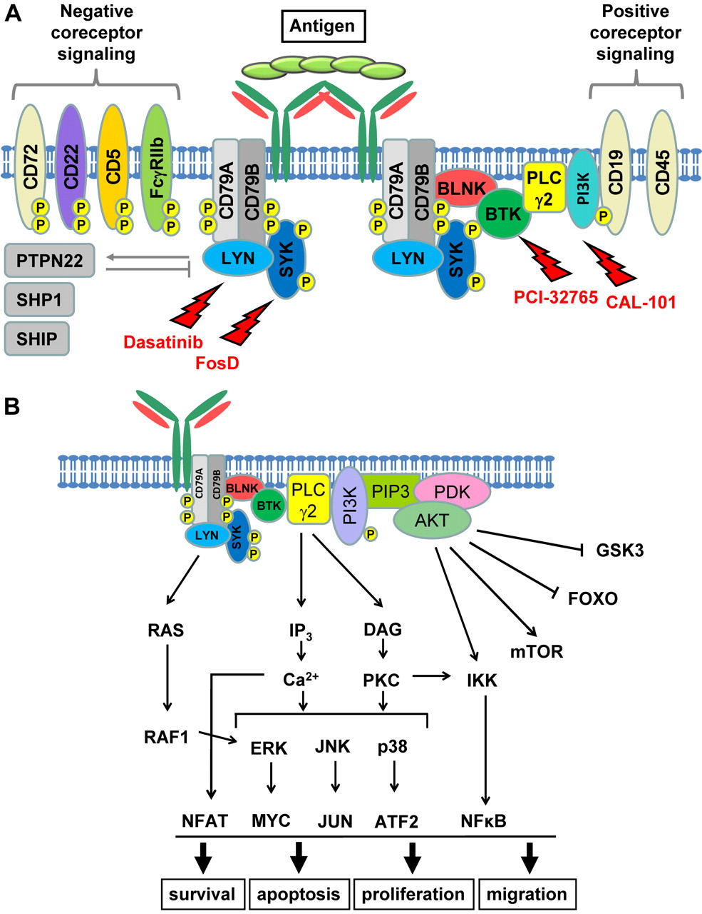

Figure 2. The BCR signaling pathway.

Work Cited

A.J., Sangma M.M. Ashok, Bernardi D. Bonavina L., Walter R. Oellerich T., Momose S.
Rosenwald A., Aukema S.M. Siebert R., England R.J. Millar A.J., and Minnicelli C. Hassan R. "Burkitt Lymphoma." MalaCards - Human Disease Database. LifeMap Sciences, 1996. Web. 09 Apr. 2017.

Database, GeneCards Human Gene. "MYC Gene(Protein Coding)." GeneCards Human Gene
Database. LifeMap Sciences, 1996. Web. 09 Apr. 2017.

Dunleavy, K., and S. Pittaluga. "NIH Study Finds Low-intensity Therapy for Burkitt Lymphoma
Is Highly Effective." National Institutes of Health. U.S. Department of Health and Human Services, 10 Aug. 2015. Web. 11 Apr. 2017.

McKusick, Victor A., and Ada Hamosh. "Burkitt Lymphoma; BL." OMIM Human Genetics
Knowledge of the World. John Hopkins, 04 July 1984. Web. 10 Apr. 2017

Roland, Walter and Kuan-Ting Pan. "HSP90 Promotes Burkitt Lymphoma Cell Survival by
Maintaining Tonic B-cell Receptor Signaling." PubMed: National Center for Biotechnology Information. U.S. National Library of Medicine, 07 June 2016. Web. 11 Apr. 2017.

